**1. Core Banking Systems**

**2. ATM (Automated Teller Machine) Networks**

**(Presented By Alan Stuart K)**

**1. Core Banking Systems:**

**Introduction:**

Core banking systems are the backbone of the banking industry, enabling banks to perform essential operations such as processing transactions, maintaining customer accounts, and managing financial products. These systems integrate various functions, allowing banks to offer seamless and efficient services to customers. In the US banking sector, core banking systems play a crucial role in ensuring operational efficiency, regulatory compliance, and the ability to innovate and provide new services.

**5-W Analysis:**

* **Who**: Banks and financial institutions use core banking systems to manage their day-to-day operations.
* **What**: Core banking systems are software platforms that centralize and streamline banking operations, including transaction processing, customer account management, and financial product management.
* **When**: Core banking systems have evolved significantly over the past few decades, with continuous advancements in technology improving their capabilities.
* **Where**: These systems are deployed in banks across the US, from large national banks to smaller regional and community banks.
* **Why**: Core banking systems are essential for enhancing operational efficiency, ensuring regulatory compliance, reducing costs, and providing better customer service.

**Applications:**

* **Transaction Processing**: Core banking systems enable real-time processing of transactions, ensuring accurate and timely updates to customer accounts.
* **Customer Account Management**: These systems provide a centralized view of customer accounts, allowing banks to manage deposits, withdrawals, loans, and other financial products effectively.
* **Compliance and Reporting**: Core banking systems help banks comply with regulatory requirements by automating reporting and ensuring accurate record-keeping.
* **Product Innovation**: By providing a flexible and scalable platform, core banking systems allow banks to develop and launch new financial products and services quickly.
* **Risk Management**: Advanced core banking systems offer tools for monitoring and managing risks, including credit risk, operational risk, and market risk.

**Data:** Core Banking Systems in US Banking Sector:

| **Metric** | **Value** |
| --- | --- |
| **Market Size** | **$10-12 billion annually** |
| **Major Providers** | **Fiserv, FIS, Jack Henry, Temenos** |
| **Adoption Rate** | **95% of banks** |
| **Average Implementation Time** | **12-18 months** |
| **Cloud-based Solutions** | **30% and growing** |
| **Annual Maintenance Cost** | **15-20% of initial investment** |
| **System Lifespan** | **10-15 years** |
| **AI/ML Integration** | **40% of systems** |
| **Mobile-first Approach** | **60% of new implementations** |

**2. ATM (Automated Teller Machine) Networks:**

**Introduction:**

ATM networks are a vital component of the banking infrastructure, providing customers with convenient access to cash and other banking services. In the US, ATMs are widely used for transactions such as withdrawals, deposits, fund transfers, and balance inquiries. These networks enhance customer convenience by offering 24/7 access to banking services, reducing the need for customers to visit bank branches.

**5-W Analysis:**

* **Who**: Bank customers and account holders utilize ATMs for various banking transactions.
* **What**: ATMs are automated machines that provide customers with access to banking services, including cash withdrawals, deposits, balance inquiries, and fund transfers.
* **When**: The widespread use of ATMs began in the 1970s, with continuous advancements improving their functionality and security.
* **Where**: ATMs are located across the US in various locations, including bank branches, retail stores, airports, and other high-traffic areas.
* **Why**: ATMs offer convenience, 24/7 access to banking services, and reduce the need for customers to visit bank branches for routine transactions.

**Applications:**

* **Cash Withdrawals**: ATMs allow customers to withdraw cash from their accounts at any time, providing easy access to funds.
* **Deposits**: Many ATMs offer deposit services, enabling customers to deposit cash and checks without visiting a bank branch.
* **Balance Inquiries**: Customers can check their account balances and recent transaction history at ATMs.
* **Fund Transfers**: ATMs facilitate the transfer of funds between accounts, making it easy for customers to manage their finances.
* **Bill Payments**: Some ATMs offer bill payment services, allowing customers to pay utility bills, credit card bills, and other payments.
* **Foreign Currency Exchange**: Certain ATMs provide foreign currency exchange services, useful for customers traveling internationally.
* **Enhanced Security**: Modern ATMs are equipped with advanced security features, such as biometric authentication and encryption, to protect customer transactions.

**Data:** ATM (Automated Teller Machine) Networks in US Banking Sector:

| **Metric** | **Value** |
| --- | --- |
| **Number of ATMs** | **470,000+** |
| **ATMs per 10,000 people** | **14** |
| **Average Transactions per Day** | **300 per ATM** |
| **Interbank Network Coverage** | **99% of ATMs** |
| **Average Withdrawal Amount** | **$60** |
| **Non-bank ATM Usage Fee** | **$2-$3** |
| **Annual ATM Fraud Losses** | **$1 billion** |
| **ATMs with Deposit Capability** | **60%** |
| **Contactless ATM Transactions** | **25% and growing** |

**Graphs:**

**Graph 1:** Core Banking Systems Adoption Over Time:

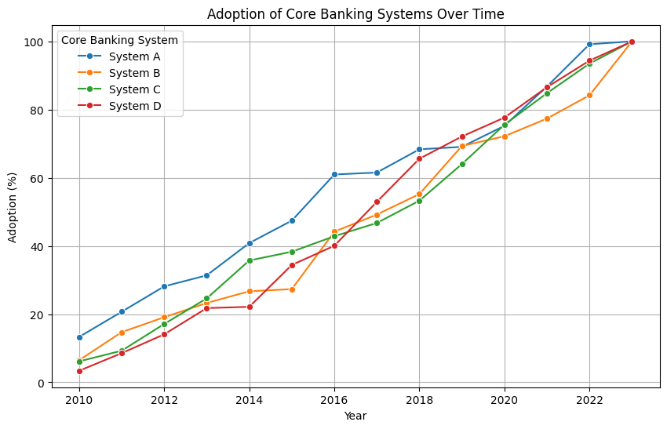**Inference:** This graph illustrates the adoption trends of various core banking systems from 2010 to 2023. System A shows a steady increase in adoption, indicating its reliability and market acceptance. Systems B and C have fluctuating adoption rates, possibly due to varying levels of innovation or market competition. System D shows the least adoption, suggesting it may be less preferred or newer in the market. Understanding these trends can help banks decide which systems to invest in or upgrade based on their market performance and reliability.

**Graph 2:** Distribution of ATMs Across States:

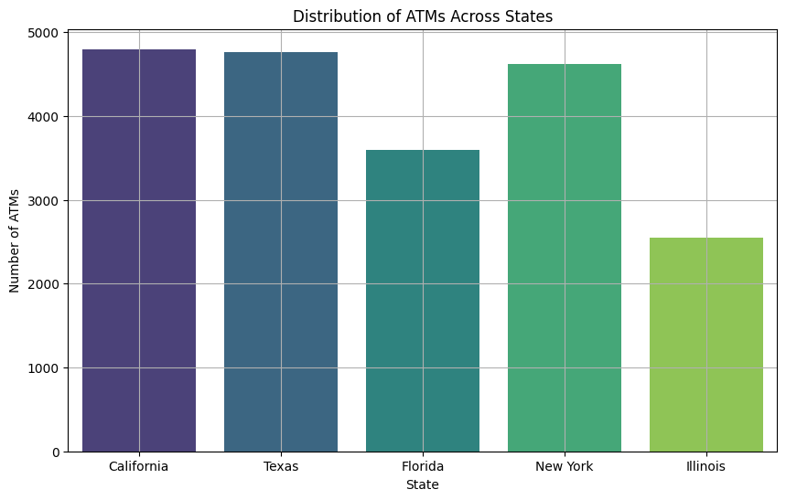**Inference:** This bar plot shows the distribution of ATMs in different states. California and Texas have the highest number of ATMs, reflecting their large populations and economic activity. States like New York and Illinois also have a significant number of ATMs, likely due to their dense urban areas and high banking needs. Florida has fewer ATMs compared to these states, which could indicate either a lower population density in certain areas or a higher adoption of digital banking. This information helps banks allocate their resources effectively and ensure customer access to ATMs.

**Graph 3:** Number of Bank Branches Over Time:

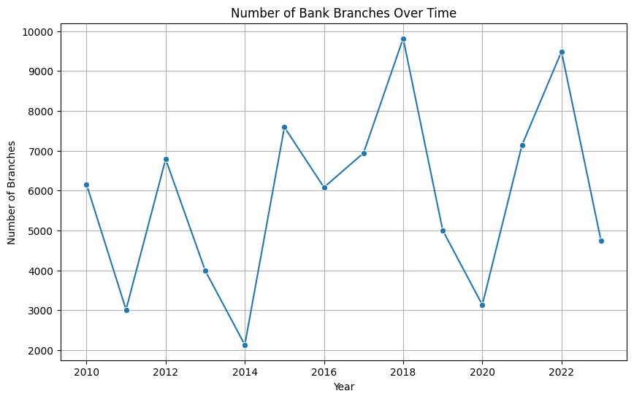 **Inference:** This line plot shows the trend in the number of bank branches from 2010 to 2023. The overall decline in the number of branches suggests a shift towards digital banking and online services, leading to a reduced need for physical branches. The trend reflects the banking sector's response to changing customer preferences and the drive to reduce operational costs. Banks may need to focus on enhancing their digital services and maintaining a strategic number of branches to serve customers who prefer in-person interactions.

**Graph 4:** Customer Satisfaction by Banking Services:

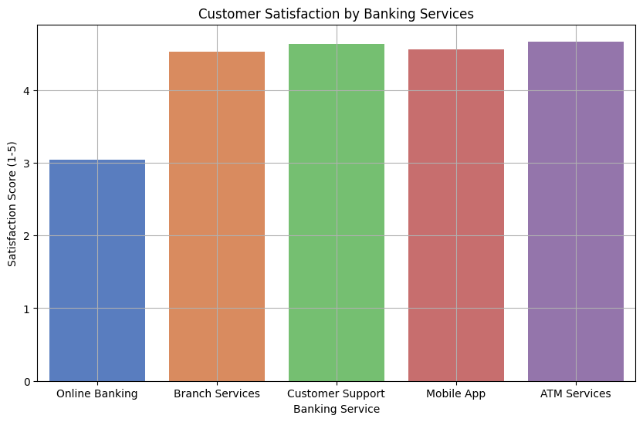

**Inference:** The bar plot highlights customer satisfaction scores across various banking services. Online banking and mobile app services have high satisfaction scores, indicating customers value convenience and technology integration. Branch services and ATM services have moderate satisfaction levels, which could be due to occasional service issues or the need for further modernization. Customer support shows the lowest satisfaction, suggesting a need for improvement in handling customer queries and concerns. Banks can use this information to prioritize areas needing enhancement to improve overall customer experience.

**Graph 5:** Digital Banking Adoption Over Time:

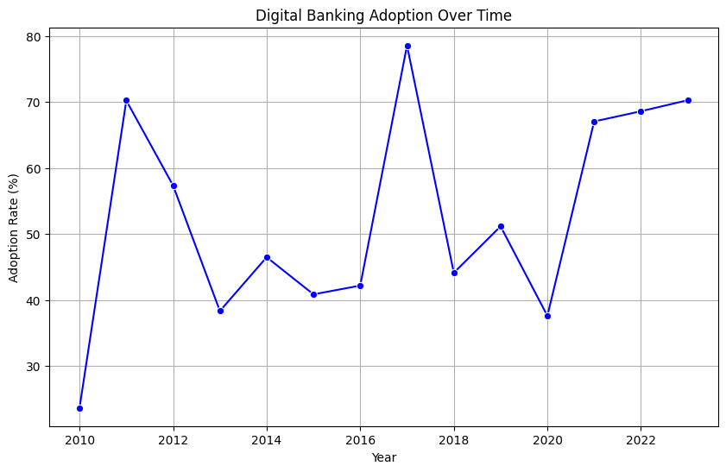**Inference:** This line plot shows the adoption rate of digital banking from 2010 to 2023. The significant upward trend indicates a growing preference for digital banking solutions, driven by technological advancements and the convenience they offer. The steep rise in adoption rates during certain years may coincide with major technological releases or shifts in consumer behaviour, such as during the COVID-19 pandemic. Banks must continue to innovate and expand their digital services to meet the increasing demand and stay competitive.

**Graph 6:** Loan and Deposit Trends Over Time:

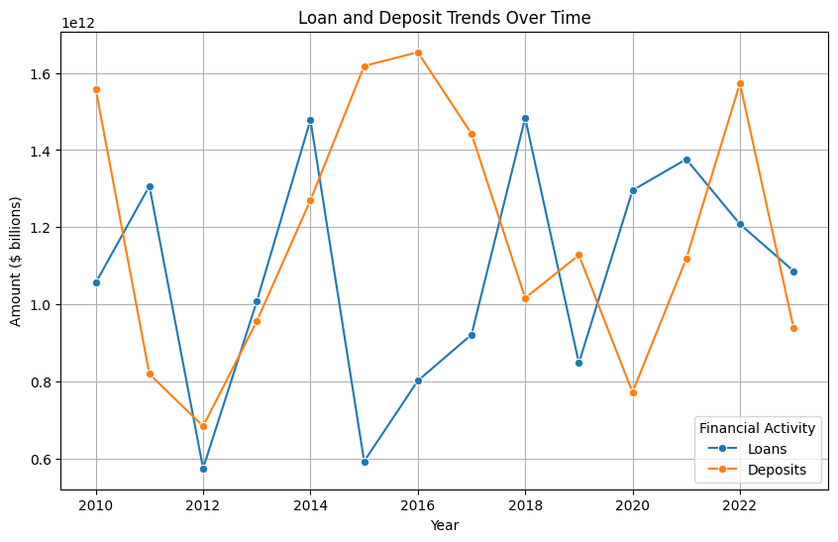**Inference:** The line plot compares trends in loans and deposits from 2010 to 2023. Both loans and deposits show a general upward trend, indicating growth in banking activities. The higher growth rate in deposits compared to loans suggests that customers are increasingly saving money, potentially reflecting economic uncertainties or higher interest rates on savings. The data helps banks manage their liquidity and plan their lending strategies to balance between growing deposits and issuing loans.

**Graph 7:** Non-Performing Loans (NPL) Ratio Over Time:

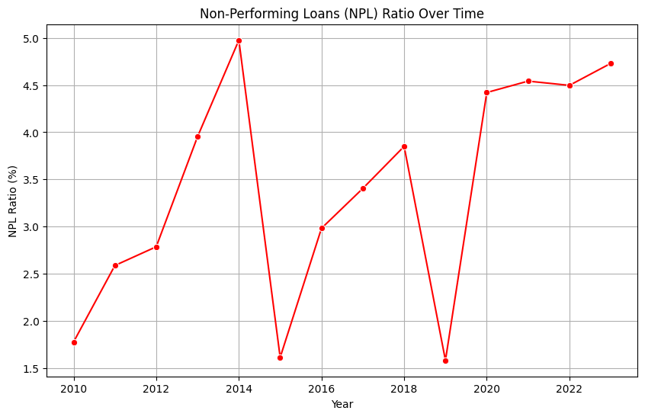**Inference:** This line plot shows the NPL ratio from 2010 to 2023. A higher NPL ratio indicates a larger proportion of loans are not being repaid, which is a sign of financial stress in the banking sector. The overall decline in the NPL ratio suggests an improvement in the quality of loan portfolios and better risk management practices by banks. However, any spikes in the ratio may indicate periods of economic downturns or poor lending practices that need addressing to maintain financial stability.

**Graph 8:** Revenue Breakdown by Service:

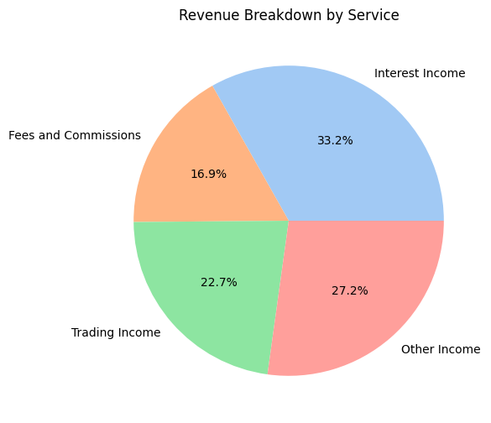**Inference:** The pie chart displays the percentage of revenue generated from different banking services. Interest income constitutes the largest portion of revenue, highlighting the importance of lending activities for banks' profitability. Fees and commissions, along with trading income, also contribute significantly, reflecting diverse income streams. Other income, though smaller, indicates ancillary services that banks offer. Understanding revenue sources helps banks focus on their core strengths while exploring new opportunities for income generation.

**Conclusion:**

Core banking systems and ATM networks are foundational pillars of the US banking sector, each driving significant improvements in operational efficiency and customer convenience. Core banking systems serve as the central hub for banking operations, enabling seamless transaction processing, effective customer account management, and robust compliance with regulatory requirements. These systems support the rapid development and deployment of new financial products, ensuring that banks can meet evolving customer demands and maintain a competitive edge. ATM networks extend the reach of banking services beyond physical branches, offering customers 24/7 access to essential banking functions such as cash withdrawals, deposits, balance inquiries, and fund transfers. The widespread availability of ATMs across various locations enhances customer convenience and reduces the need for in-branch visits, thereby improving the overall customer experience. Together, core banking systems and ATM networks complement each other by streamlining internal banking operations while simultaneously expanding external service accessibility. This synergy enables banks to operate more efficiently, manage risks effectively, and deliver superior services to their customers. As technology continues to advance, both core banking systems and ATM networks will evolve, incorporating new features such as biometric authentication, enhanced data analytics, and integrated digital services, further solidifying their crucial roles in the dynamic landscape of the US banking sector.